DAY 3

DEVOPS

STEP -1: CREATE THE DIRECTORIES AND CREATE PACKAGE.CSV AND TYPE THE FOLLOWING CODE.

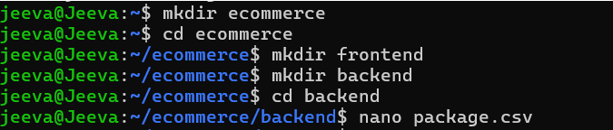

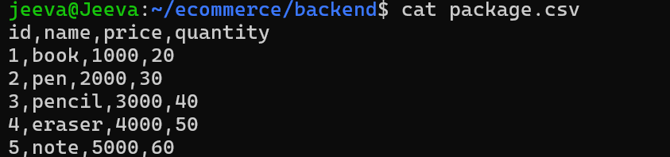

STEP -2 :TO READ AND WRITE THE FILE:

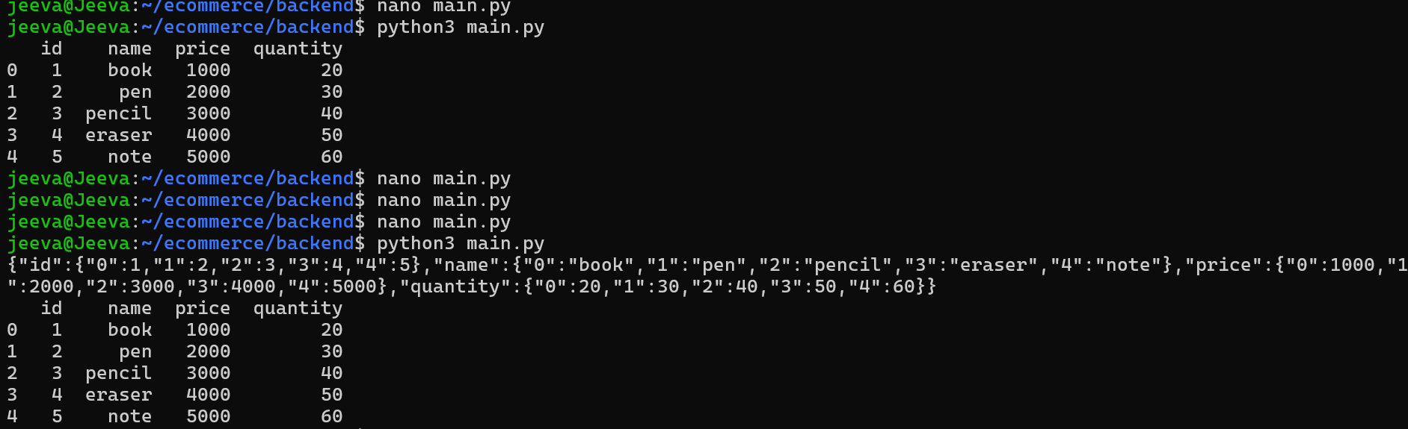

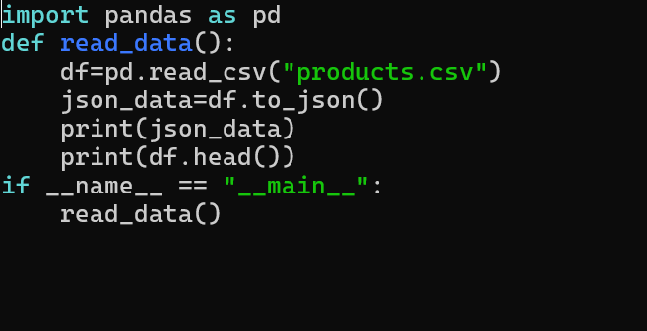

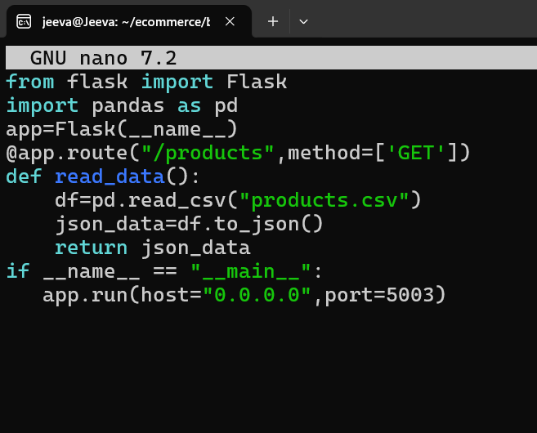

STEP-3 :CREATE DOCKERFILE

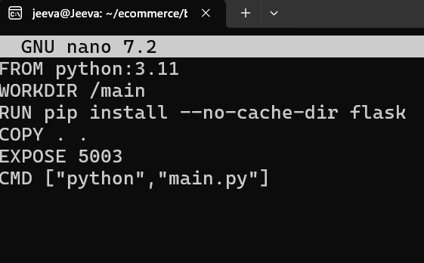

STEP-4 : CREATE REQUIREMENTS.TXT

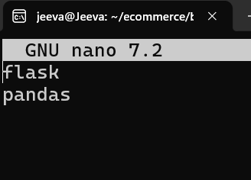

STEP 5:CREATE docker-comper.yml file

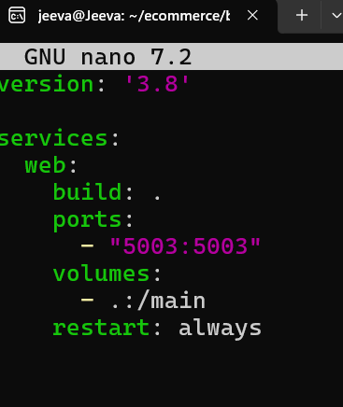

STEP-6 : BUILD AND RUN THE APPLICATION LOCALLY

1)BUILD DOCKER IMAGES

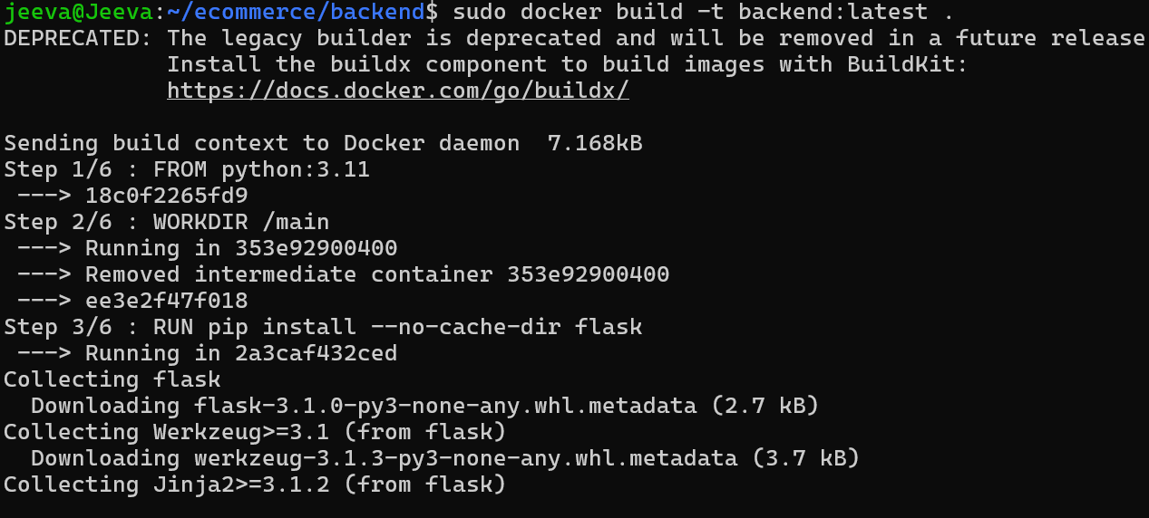

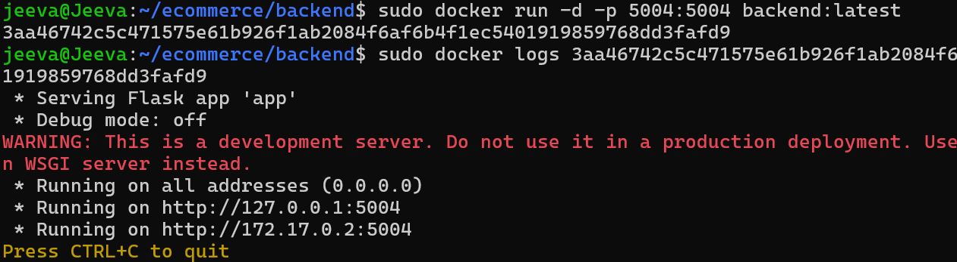

2) IN LOCALH0ST SEE THE OUTPUT

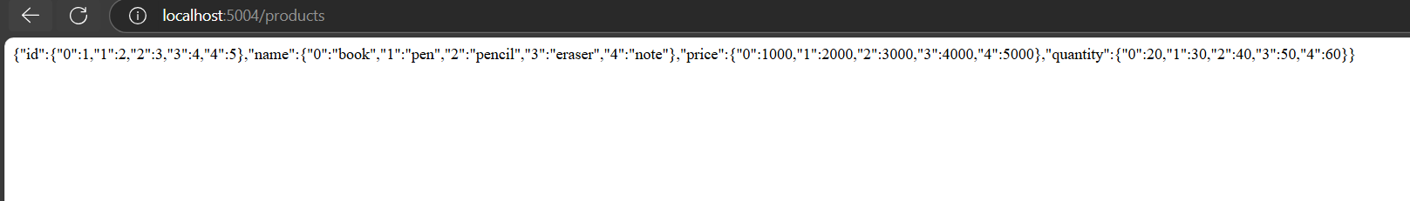

STEP -7: IN FRONTEND CREATE INDEX.HTML

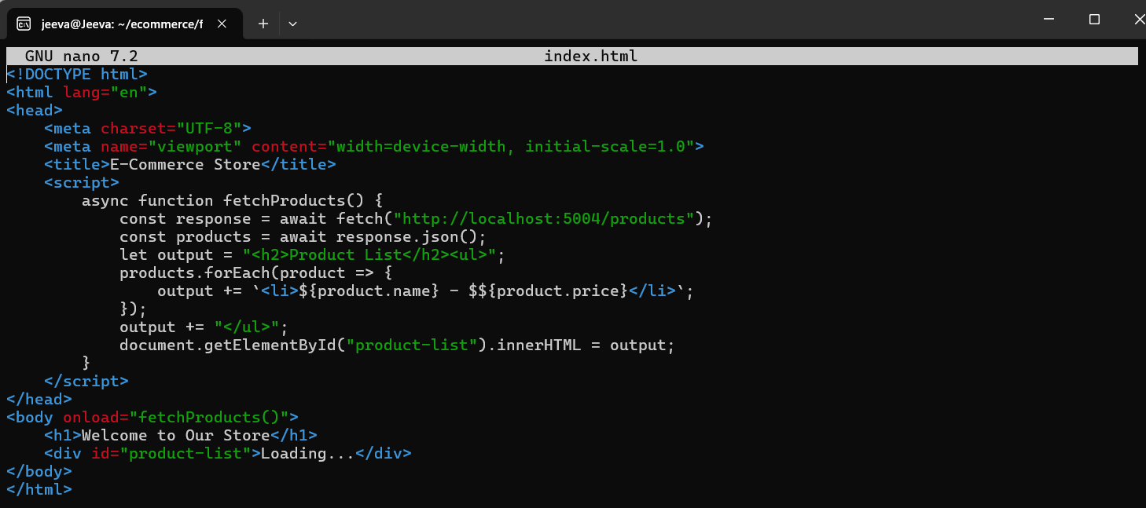

STEP-8: IN FRONTEND THE DOCKERFILE

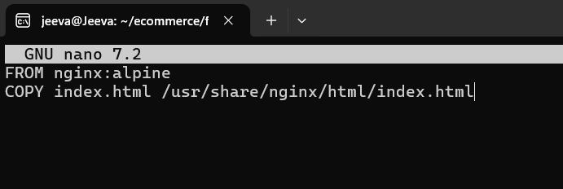

STEP-9 : CREATE A FRONTEND BUILD FOR DOCKER

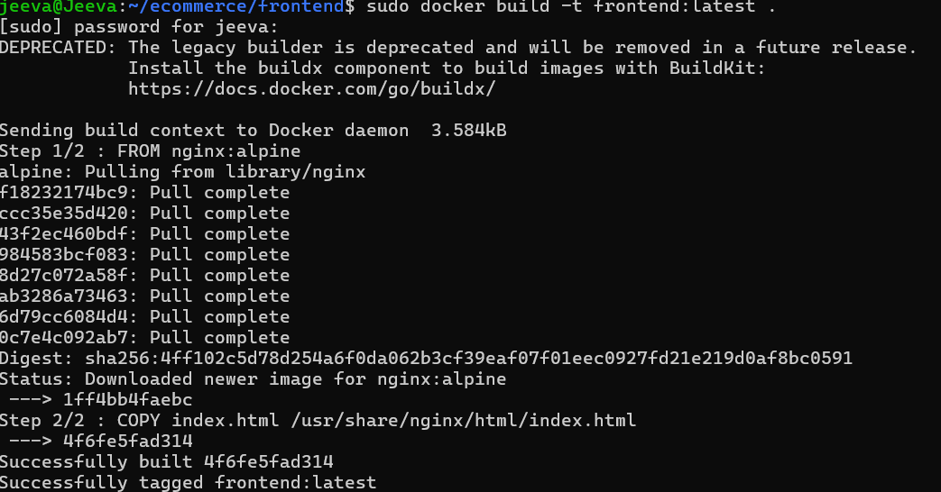

STEP-10 : CREATE KUBERNETES DEPLOYMENT YAML FILES

K8s/backend-deployment.yaml



STEP-11 CREATE CONFIGURE FILE FOR BACKEND-DEPLOYMENT.YAML

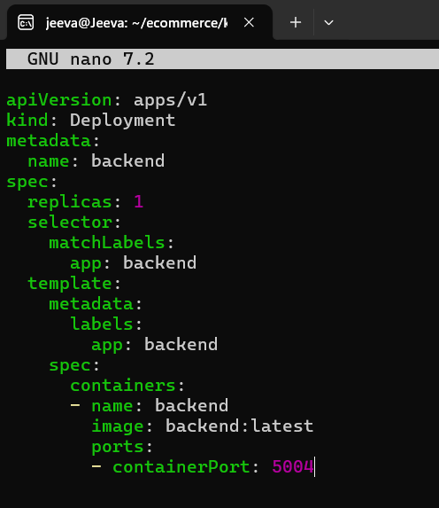

STEP-12 : CREATE A FRONTEND::FRONTEND-DEPLOYMENT.YAML

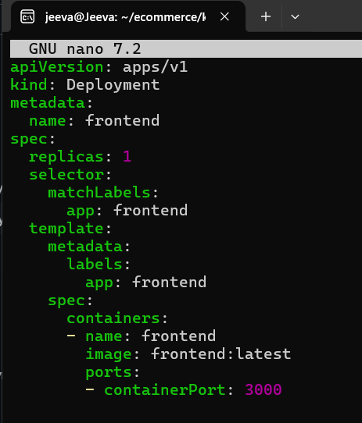

STEP-13:CREATE SERVICE.YAML

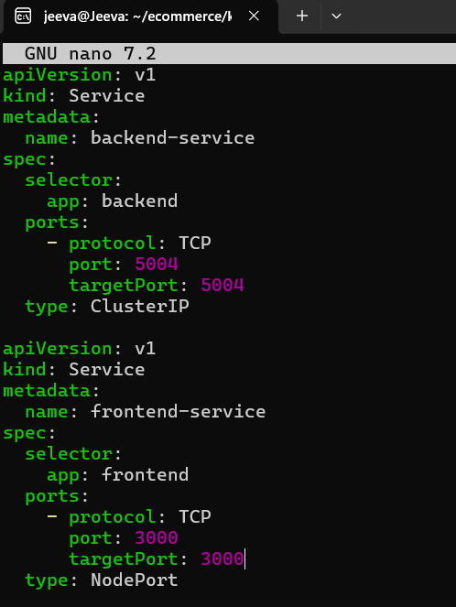

STEP-13:CREATE configmap.yaml

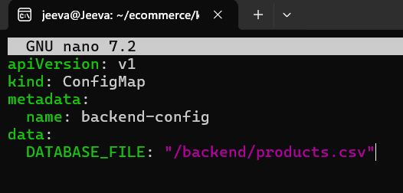

STEP-14 BUILD AND RUN THE APPLICATION LOCALLY

1)INSTALL THE MINIKUBE

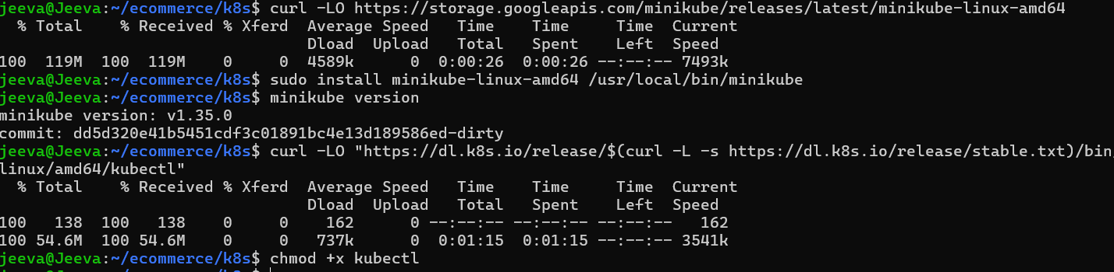

TO MAKE IT EXECUTABLE

chmod +x kubectl

MOVE TO A SYSTEM PATH

sudo mv kubectl /usr/local/bin/

VERIFY INSTALLATION

kubectl version –client

DAY-4

DEVOPS

CLONING:

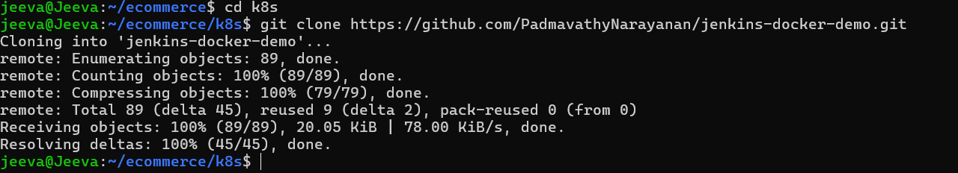

STARTING MINIKUBE

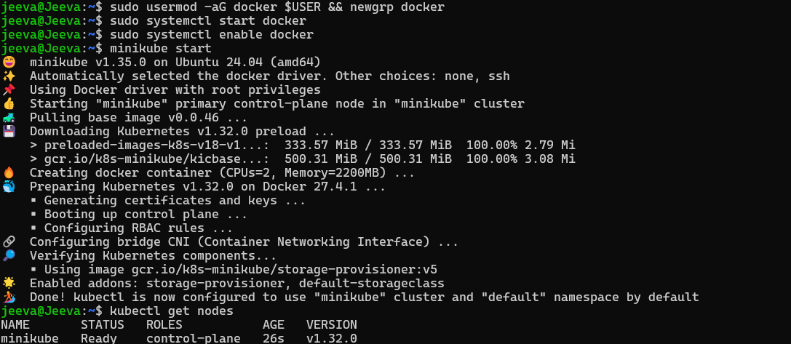

TO RUN AN APPLICATION LOCALLY

TO BUILD A BACKEND FOR MINIKUBE

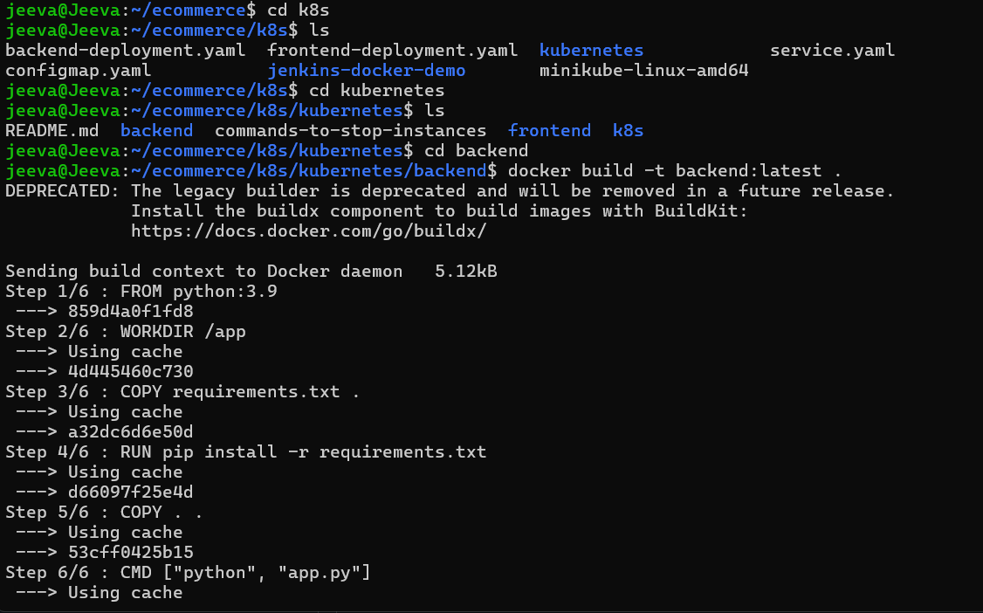

#user folder

eval $(minikube docker-env)

# Navigate to backend folder

cd backend

docker build -t backend:latest .

#Then verify the image exist:

docker images | grep backend

minikube image load backend:latest

TO BUILD A FRONTEND FOR MINIKUBE

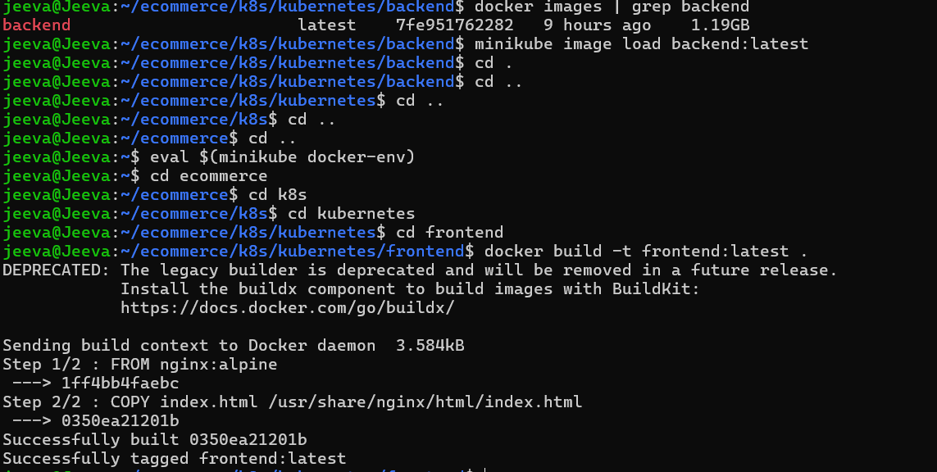



To create a Deployment file for Kubernetes for frontend, Backend, service.yaml,

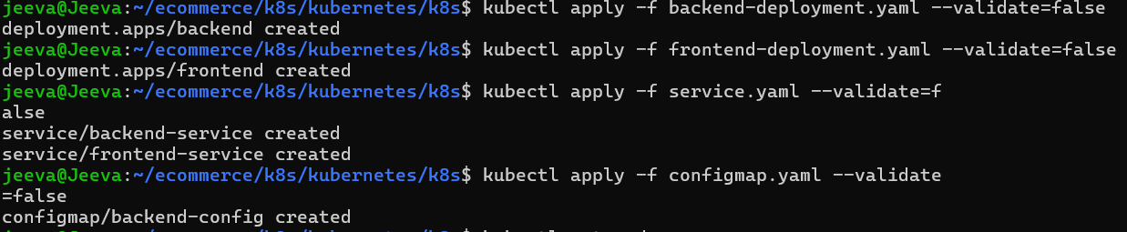

TO CREATE PODS AND SVC

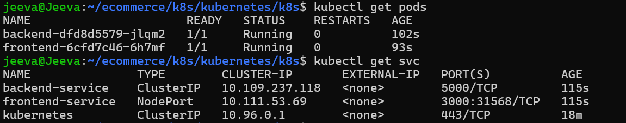

To check the output:

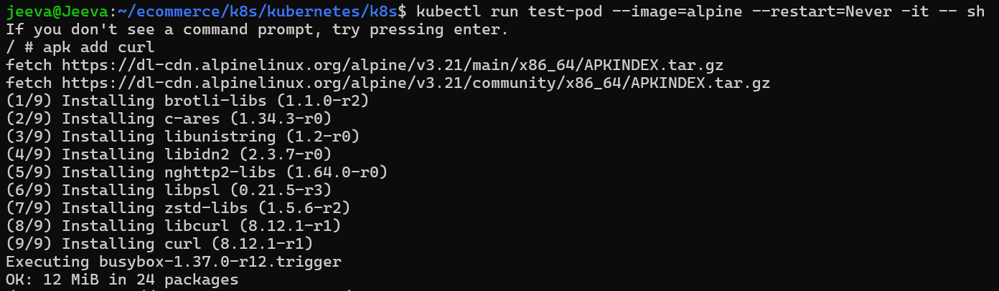



TO VERIFY THE OUTPUT IN FRONTEND:  


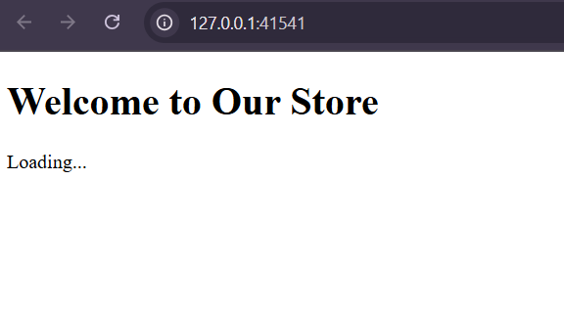

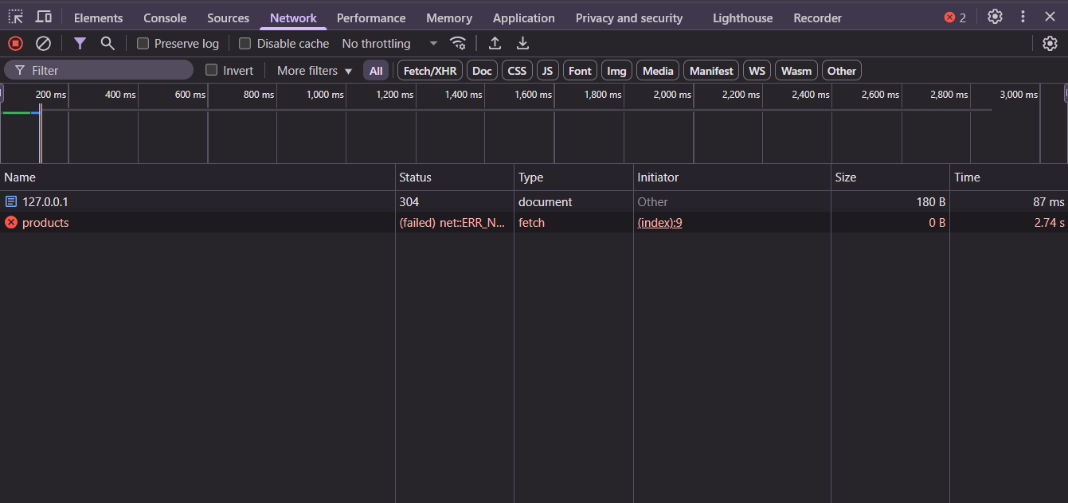

In inspect page we are expected this kind of output, because we are running this frontend in localhost.